June 2020
Lunch is Free to all Students
Menu is subject to change.
Monday |  | Tuesday | Wednesday | Thursday | Friday
1  Hamburger on WG Bun  Carrots  fruit |  | 2  Popcorn chicken  Corn  fruit | 3  Nacho Grande w/ cheese and meat  Beans  fruit | 4  Soft shell Pulled Pork Taco w/ cheese  Celery  fruit | 5  Cheese & Pepperoni Pizza  Carrots  fruit
8  Chicken Patty with WG Roll  Salad  Fruit | 9  Meatball Sub  Beans  Fruit |  | 10  Mac and Cheese w/ roll  Broccoli  Fruit | 11  Hot dog on WG Bun  VBlend Juice  Fruit | 12  Cheese & Pepperoni Pizza  Green Beans  Fruit
15  Popcorn chicken  Corn  Fruit |  | 16  Soft Taco w/meat and Cheese  Beans  Fruit | 17  Turkey w/ gravy  Mashed potato  fruit | 18  Hot Dog on WG Roll  Carrots  Fruit | 19  Cheese & Pepperoni Pizza  Celery  Fruit
22  Chicken Nuggets w/ crackers  Mixed veg.  Fruit |  | 23  Taco in a Bag with meat and cheese  Beans  Fruit | 24  Pasta w/ meat sauce w/Roll  Salad  Fruit | 25  Hamburger on WG Roll  Carrots  Fruit | 26  Cheese & Pepperoni Pizza  Mixed veg.  Fruit
29  Hot Dog on WG Bun  Fresh tomato  Fruit |  | 30  Popcorn Chicken  Salad  Fruit
Holley School
Lunch Menu
Start with a:
• Vegetable
• Fruit (or take both)
• Choose whole grains
• Pick a lean protein
• Add serving of milk
Take at least 3
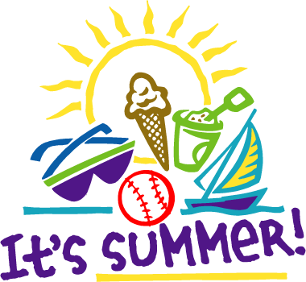

Offered daily
with all School Lunches:
fresh or prepared fruits
(Must take ½ cup of Fruit or Veggies)

Non or Low Fat White or
Non Fat Chocolate Milk available daily

Lunch Fact
MyPlate
recommends:
Choose vegetables rich in color! Brighten your plate with vegetables that are red, orange, or dark green. They not only taste great but also are good for you, too.
Reference: USDA. MyPlate.gov. Internet: http://www.myplate.gov/.

September

Holley Elementary
School
Lunch Menu

