June 8, 2020

Parents/Guardians of 6th Graders:

Thank you to everyone who completed the parent survey about Moving-Up Day. It is such a special day for our 6th graders and families and we want to make it as memorable as possible. The result of the survey was 66% pre-recorded ceremony and 34% live-stream. Therefore, we are in the process of producing a special recorded ceremony that includes everything we normally present in the ceremony other than actual students. Instead, we will include each 6th grader’s picture and name scrolling across the screen.

But, we are not done yet! As of last Friday we received NYS Health Department guidance for Drive-Through ceremonies! This morning we planned a wonderful Drive-Through ceremony for our graduating 6th graders. I am so excited to be able to offer this experience for the children and for our 6th grade families. So, here is the NEW plan for the celebration of our 6th graders and all of their accomplishments.

- Tuesday June 16, the recorded Moving Up Day video will be released. It includes all of our accomplished award winners as well as a video tribute to our “graduates”.

- Tuesday June 16, we will have a 6th Grade Moving Up Day Drive-Through celebration. There will be 2 time slots to choose from: 1:00-3:00 and 4:00-6:00. You can pick any time to come within those time frames. At this celebration, your 6th grader will receive their “Diploma”, memory book, awards, report card and a special gift from the teachers. There will be an opportunity to take pictures and say good-bye to this year’s teachers. This will sadly be their last trip as a Holley Elementary student around the front loop.

- We are no longer planning to deliver gifts and diplomas on June 17 since it will be distributed at the Drive-Through ceremony.

- Students will also receive their fun class video, full of pictures you have submitted. (Now they will have 2 videos to remember the day by! )
- Lastly, I have 1 request. If your 6th grader still has any library books, an instrument or laptop, please bring them to the Drive-Through, we will be collecting them.

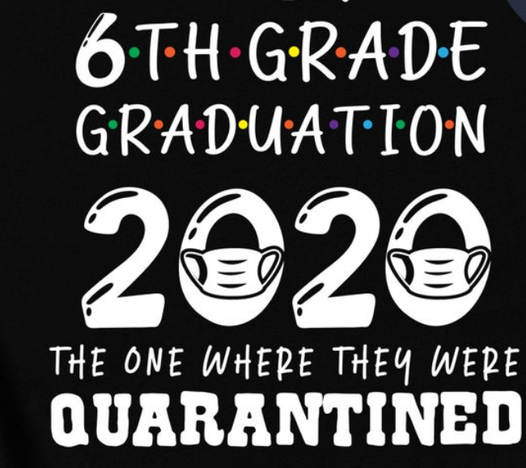

Drive-Through Reminders to keep us all healthy and safe:

- The Drive-Through Celebrations take place in front of the Elementary School, during specific times for your class/grade.
- Please pull into the front loop and wait in your car until it is your turn.
- Only members of the child’s household can come to the celebration.
- If your child lives in 2 different households, both households are welcome. Please coordinate with each other so that you are in line (in your own cars) together. Both households can watch your child receive his/her certificate awards and gift and then you will have the opportunity for pictures.
- Anyone who exits the car for photos or certificates must wear a mask (they can be removed for pictures).
- If you want a family photo, we will wear gloves and use your phone/camera.
- School personnel will be wearing masks, but masks can be removed for pictures.
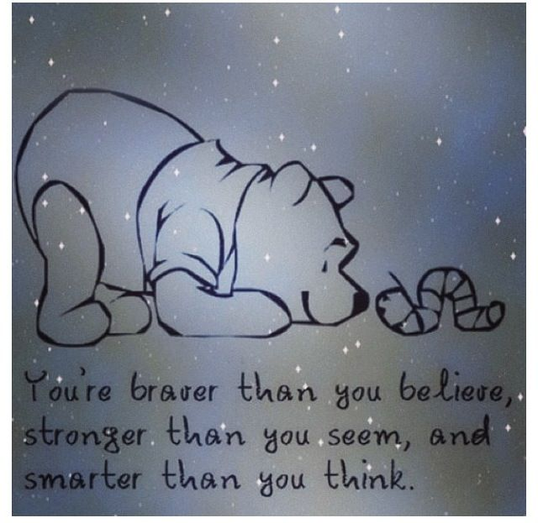
- We have adult and child masks available, as well as sanitizer if needed.

I thank you for being part of this decision making process. Stay positive, stay healthy, stay Holley Strong! Please feel free to contact me with any questions or concerns,
Karri D. Schiavone

