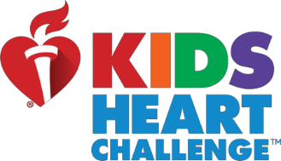

**10 Day “Virtual” Heart Healthy Challenge!!**Register Today – **Challenge Starts Monday, April 13th!!**

Dear Parent/Guardian,

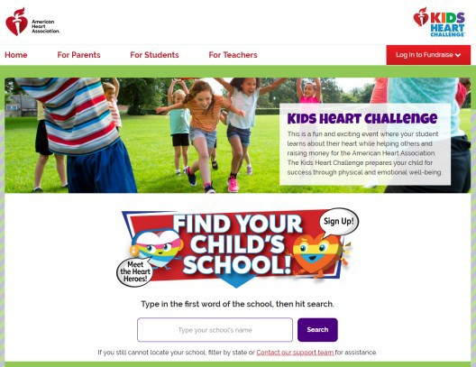It’s time for the **10 Day “Virtual” Heart Healthy Challenge!!** Did you know that heart disease is the leading cause of death for all Americans, and up to 80% of it may be preventable through lifestyle changes? The **10 Day “Virtual” Heart Healthy Challenge** is an interactive program helping students & families remain active while learning virtually.



**1.**

# Here’s how it works:

* 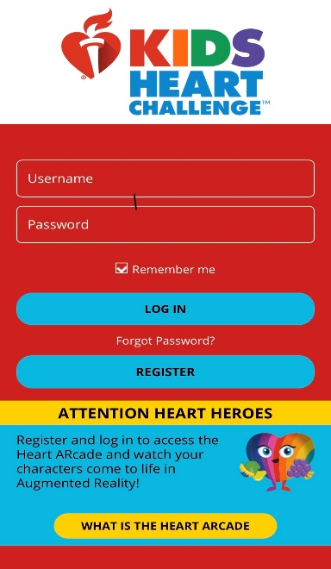Log on to **heart.org/KidsHeartChallenge**, or search **“Kids Heart Challenge”** in your app store and download the free mobile app.



**2.**

* Find your school and get registered.
* If you already registered for the **Kids Heart Challenge** there’s no need to register again. ***If you’re not registered, now’s your chance to sign-up and play along.*** It’s FREE and there’s no obligation to fundraise.

As part of the **10 Day “Virtual” Heart Healthy Challenge**, families will receive a daily 30 minute physical activity challenge, take part in the **“kindness challenge”** and receive daily suggestions for activities to complete as a family. As part of Finn’s Mission, families will also learn the warning signs of stroke, hands-only CPR and much more!! We encourage you and your family to share your progress on the Kids Heart Challenge Facebook and Instagram pages too!!

We hope you enjoy the **10 Day “Virtual” Heart Healthy Challenge** and thanks to our partners at the **American Heart Association** for joining together with us to share this challenge with you. Stay active and well.

# Sincerely,

Physical Education Department